

Access Guide
  - Information for people with disabilities and anyone who may need support or extra planning.
  - Screen reader accessible version

Table of Contents

Introduction 2
Useful Contacts 3
Airline Contacts 4
Before Your Trip 6
What to bring 7
Support you can organise with Adelaide Airport 8
Meet & Assist Service 9
Customer Experience Access & Inclusion Team 9
Hidden Disabilities Program 10
On the Day of Your Trip 12
Getting to and from Adelaide Airport 13
Public Transport 14
At the Airport 15
Checking in 18
Accessible & Inclusive Facilities 18
Security Screening 22
Getting to Your Gate and Boarding 24
At Your Gate 25
Arrivals Process 26
Getting out of the Airport 27
Thank You for using this Access Guide! 28

Introduction
Adelaide Airport aims to make travel easy for everyone.
The Access Guide provides information on accessible facilities, services, and support in the terminal to help travellers with disabilities navigate the airport smoothly.
If you can’t find what you’re looking for, please visit our website here for more information.
Link: https://adelaideairport.com.au
Please note that this document is an alternative format of our Access Guide, designed for screen reader accessibility. This version includes all the same information as the standard Access Guide. Images are only included where they provide additional context, and all images include alt text descriptions. Hyperlinks are also written out in full. See our website for other versions of the Access Guide. If you need the Guide in a different format, please contact us:
Email: accessandinclusion@aal.com.au
Phone: 08 8154 9587
Text: 0485 990 823

Useful Contacts

Customer Experience Team (Access and Inclusion)
For help with customer enquiries, accessible information, airport familiarisation tours, emotional and peer support at the airport, sensory room questions or bookings
Email: accessandinclusion@aal.com.au
Phone: 08 8154 9587
Text: 0485 990 823
Hours: 8:30 am to 4:30 pm, Monday, Tuesday, Wednesday, and Friday

Airport Management Centre (General Enquiries)
For flight information, enquiries about services and facilities in the airport, car park booking enquiries
Phone: (08) 8308 9211
Email: customerfeedback@aal.com.au
Hours: 9:00 am to 5:30 pm, Monday to Friday

Customer Service Officers (CSOs)
For luggage, mobility help, loan wheelchairs moving through the airport
Phone: (08) 8308 9380 or 0438 890 024
Hours: 7 days, 4:30 am to 11:30 pm

Lost Property (Welcome Desk)
For items left in the terminal, general information, getting a Hidden Disabilities Sunflower Lanyard
Location: Welcome Desk (ground floor, base of escalators, near baggage collection)
Lost Property form
Hours: Mon–Fri: 7:30 am to 9:30 pm
Weekends: 7:30 am to 5:30 pm

Items left on the plane
Contact your airline directly (details on next page)

Airline Contacts

Airline | Phone | Website
Air Asia | +61 0238138388 | airasia.com
Air New Zealand | 13 24 76 | www.airnewzealand.com.au
Alliance Airline | 1300 780 970 | allianceairlines.com.au
Cathay Pacific | +61 131 747 | www.cathaypacific.com
China Southern | +8620-22395539 | csair.com
Emirates | 1300 303 777 | emirates.com
Fiji Airways | 13 34 54 (13 FIJI) | fijiairways.com
Jetstar | 13 15 38 | Jetstar.com.au
Malaysia Airlines | 13 26 27 | www.malaysiaairlines.com
Maroomba Airlines | +61 8 9463 4900 | maroomba.com.au
National Jet Express | 0498 209 312 | webcheckin.nje.aero
Platinum Aircraft Charter | 1300 856 597 | flyplatinum.com.au
Qantas | 13 13 13 | Qantas.com.au
Qantas Link | 13 13 13 | qantas.com
Qatar Airways | 1300 340 600 | qatarairways.com
Regional Express (Rex) | 13 17 13 | Rex.com.au
Sharp Airlines | 1300 556 694 | sharpairlines.com
Singapore Airlines | 61 (02) 7209 4388 | singaporeair.com
United Airlines | 13 17 77 | united.com
Virgin Australia | 13 67 89 | Virginaustralia.com.au

Before Your Trip

Booking support with your airline

If you need help with:
Transferring to and from your plane seat
Ask what transfer method will be used (aisle chair + assisted transfer, slide board, transfer sling, “Eagle” lift where available).
You use a hoist at home or can’t do a manual/slide-board transfer safely
Ask whether they can accommodate your needs on that aircraft, and what assistance/equipment is available.
Keeping your mobility aid or medical equipment safe
Ask about battery and handling requirements and where/when your chair will be returned.
Using the aisle chair
Ask whether one is available and how boarding/disembarking will work.
Managing anxiety or panic
Ask about pre-boarding, quiet waiting spaces, and communication options.
You might miss audio announcements
Ask for visual/written updates or direct check-ins.
Sensory overload
Ask for quieter boarding or step-by-step explanations.
Travelling with a support person
Ask about seating and assistance policies.
Medical equipment/medication
Ask what you can bring and documentation required.
You need extra time
Ask about check-in timing and arrival recommendations.
Arrange mobility help to the gate
Usually arranged through your airline.

What to bring

If you have them, bring supporting information (paper or phone):
- Medical letter or plan explaining your needs, from a legally qualified medical practitioner, on official letterhead with provider details
- Medication and extras
- Medical equipment needed during flight
- Chargers and spare batteries
- Medication labels or list
- Equipment notes (e.g. batteries, devices, liquids)

For security screening, it can help to have:
- List of medical items
- Travel cards or documents
- Booking confirmation for assistance

Quick tips
Keep important items together in a clear pouch.
You don’t need to share a diagnosis.

Support you can organise with Adelaide Airport
You can organise support before you travel. This is separate from airline assistance like onboard seating, aisle chairs, and transfers.

Meet & Assist Service
Customer Service Officers (CSOs) can assist you at the terminal with practical support like wheelchair help, luggage handling, wayfinding guidance, and general assistance as you move through the airport.
Available daily from 4:30am to 11:30pm.
Phone: (08) 8308 9380 or 0438 890 024
Extra option: there are assistance phones in the terminal that connect directly to the CSO team.

Customer Experience Access & Inclusion Team

General information and feedback
If you have questions about travelling through Adelaide Airport with a disability, or you want to share feedback about access and inclusion, contact this team.
8:30am to 4:30pm, Tuesday to Friday.
Email: accessandinclusion@aal.com.au
Phone: 08 8154 9587
Text: 0485 990 823

Airport Familiarisation Tours
A chance to practise key parts of the airport process ahead of travel day, with a supportive staff member. This can include finding your way around, locating check-in, understanding the layout, planning breaks, and talking through what to expect. Request using the contact details above.

Passenger Assist
Support on the day you travel. if you need help navigating the terminal, going through security, managing sensory overwhelm, or reducing stress. This is similar to a tour, but on the day of your trip, helping to keep things calm and organised so you feel supported.
Request using the contact details above.

Hidden Disabilities Program

Social Stories and Visual Guides
These are designed to help people understand each step of the airport journey, from check-in to boarding.
See our guides here: https://adelaideairport.com.au/accessibility/easy-english-guides

Sensory Maps
Sensory maps help you plan your route by showing areas that are busier or quieter, including information about light, noise, and crowd flow.
See our sensory maps here: https://adelaideairport.com.au/accessibility/sensory-maps

Elmo, Adelaide Airport Facility Dog
Calming walks with Elmo are a free 45-minute support service to help travellers feel calm and comfortable before flying. Available to anyone, including first-time flyers, anxious flyers, and travellers with hidden disabilities.
Service hours: Monday, Tuesday, Thursday, Friday 9:00am to 5:00pm.
Not available Wednesday, weekends, or public holidays.
How to book: complete the facility dog booking form here: https://adelaideairport.com.au/accessibility/hidden-disabilities

Sensory Room
A free quiet space designed for passengers who need a break from the busy terminal. It includes adjustable soft lighting, comfortable seating and nooks, calming visuals, tactile items, and fidget tools.
Opening hours: Monday to Friday: 7:30am to 9:30pm
Saturday, Sunday, public holidays: 7:30am to 5:30pm
Location: between the Virgin Australia Lounge and the Airport Pharmacy. Turn left after security.
How to book: via the Adelaide Airport website. If you need help making a booking, contact the Access and Inclusion Team.
Link: https://adelaideairport.com.au/accessibility/sensory-room/

Sunflower Lanyards
A discreet way to let trained staff know you may need extra time, flexibility, or clear communication. Not everyone can or wants to wear a lanyard. If a lanyard doesn’t work for you, you can still ask for help and use the Assistance Lane at security.
Some people prefer to keep the sunflower item on a bag, wear it another way, or simply tell staff they have an access need.
How to request and collect:
Request online before you travel using the hidden disability request form here:
https://adelaideairport.com.au/accessibility/hidden-disabilities/sunflower-lanyard-request-form/
Someone else can collect it for you if needed.
Collect from the Welcome Desk, Level 0.
Monday to Friday 7:30am to 9:30pm
Saturday, Sunday 7:30am to 5:30pm

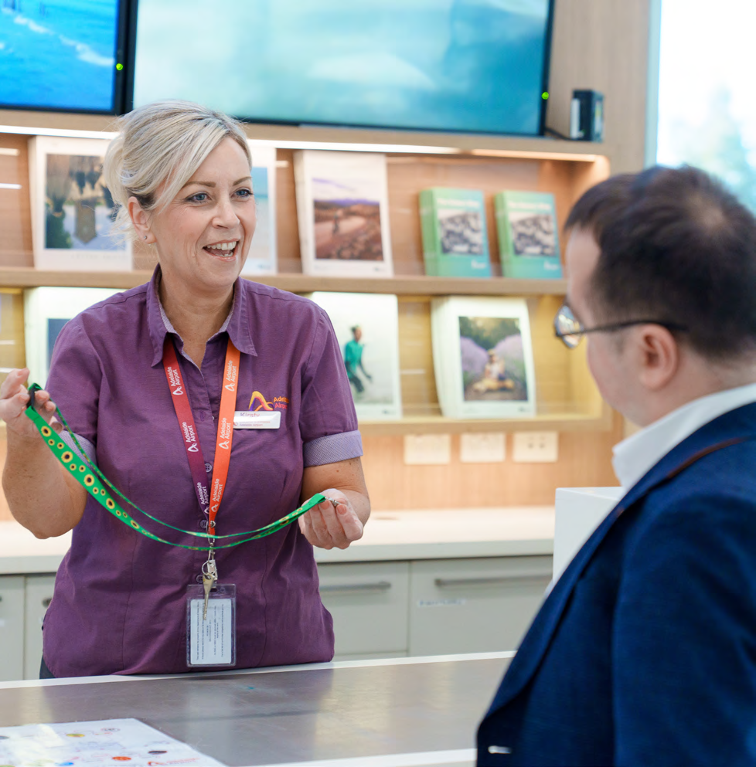

On the Day of Your Trip

When to arrive
Adelaide Airport is open from 3:15am to 11:30pm every day.
We recommend arriving at Adelaide Airport with enough time to check-in, drop bags (if needed), and move through the terminal without feeling rushed.

Domestic Flights Within Australia
Arrive at least 1 hour before departure.
If you use a mobility aid, are travelling with medical equipment, need extra time, or want to feel settled, aim for 60 to 90 minutes before your flight time. This also gives you time to spend in our Sensory Room or have your calming walk with Elmo if you have arranged these.

International Flights to Another Country
Arrive 2 to 3 hours before departure.
International travel involves extra steps and can take longer.

Getting to and from Adelaide Airport

Driving and Parking
Adelaide Airport’s address is:
1 James Schofield Drive Adelaide Airport South Australia.

P1 Terminal Car Park
Short stay, closest to the terminal
P1 is directly next to the terminal, located 100 metres from the terminal doors. It has 26 accessible bays near the lifts, marked with blue on the car space.
If you need help, use the intercom/help button at entry, exit, or pay stations, or call the Car Park Office.

P2 Outdoor Car Park
Affordable and convenient
P2 Outdoor Car Park is a 425 metre walk from check-in, with ticketless entry, and free luggage trolleys to make your journey smoother.
Priority bays for disability permit holders are located close to passenger exits along the walkways.

P3 Long Term Car Park
Best value, longer trips
P3 is a 440 metre walk to the terminal and has free luggage trolleys.
Priority bays for disability permit holders are located close to walkways.

Accessible Parking
Rules and help
A valid disability parking permit must be clearly displayed.
All car parks are open 24/7.

Quick tips
If you need to take your disability parking permit with you while travelling, contact the Car Park
Office ahead of your trip:
(08) 8308 9380 or carparkoffice@adelaideairport.com.au

Pick-up and Drop-off
Access Zone near Atura Hotel
closest, easiest option for many people with disability. The Access Zone is on Atura Circuit, between the terminal and the Atura Hotel. It has three accessible spaces and a disability parking permit or signage showing the vehicle belongs to an organisation that provides transport to people with disability is required.
The main drop-off and pick-up areas are between P1 Terminal Car Park and the terminal plaza and are clearly signposted.
Stay with your vehicle at all times. If your passenger is not ready, do a lap and come back through.

Public Transport

Bus Information
Adelaide Airport is served by Adelaide Metro buses. There is no direct train or tram to the terminal.
You’ll be dropped off at Stop 10 on Sir Richard Williams Avenue, which is a 2–5 minute walk from the terminal. Luggage trolleys are located near the stop.
Services include J1 and J2 for city routes and J7 and J8 for suburban routes.

Taxi and Rideshare
Taxis can drop you at Atura Circuit, between the terminal and the Atura Hotel.
To find the taxi rank when leaving the airport, exit the terminal and turn left in the plaza, following the “Taxi Rank” signs.

If you need a wheelchair accessible taxi, you can call Adelaide Access Taxis.
Phone: [ one three hundred, three six zero, nine four zero]

Rideshare (Uber, Ola, DiDi)
Rideshare pick-up is in a designated area to the left of the Terminal Car Park. Follow the rideshare signs through the plaza, cross at the pedestrian lights into the car park, and the pick-up zone is on your left.
Use your app to confirm the correct pick-up zone.

If you need help getting inside
Contact our Meet and Assist service.
Phone: (08) 8308 9380 or 0438 890 024
There are also Assistance Phones just inside the terminal doors that will connect you straight to them.

At the Airport

Getting help
If you are lost, unsure what to do, or you have questions, there are a few different ways to get help.

The Welcome Desk
The Welcome Desk is on level 0, also known as the ground floor, by the escalator. The staff here can tell you where things are, how to get to different areas of the airport, answer questions about what is happening at the airport and more.
They can also help you with lost property, and this is where you can pick up your Hidden Disabilities Sunflower Lanyard if you have requested one.
Monday to Friday 7:30am to 9:30pm
Saturday, Sunday 7:30am to 5:30pm

Volunteer Ambassadors
Our Volunteer Ambassadors spread out to cover different areas of the terminal, so they are ready to answer your questions and help you find your way around. Look for the maroon uniforms.
Hours: 3:15am to 11:30pm, 7 days a week.

Airport Staff
Any staff member wearing an Adelaide Airport staff lanyard will be happy to
help. Our staff lanyards come in two different designs, both pictured.

Checking in
All airline check-in desks are on level 2 of the airport. Most are inside the terminal itself, and some are in our temporary check-in hall while we expand the terminal.
The temporary check-in hall is just outside the doors on level 2.

How to Check In
Option 1: Check-in online (before you arrive)
You can usually check-in using your airline’s website or app. Online check-in can save time at the airport and may let you:
- Confirm your details and seat, if available
- Receive a mobile boarding pass
- Go straight to bag drop if you have checked luggage.

Option 2: Check-in at the airport
You can check-in at your airline’s check-in desk at Adelaide Airport. This option can be helpful if you:
- have a mobility aid (for example, a wheelchair or scooter)
- need to check-in medical equipment or other large objects
- have arranged airline assistance and want to confirm the details in person
- prefer face-to-face support or have questions on the day

Accessible & Inclusive Facilities

Changing Places
Changing Places bathrooms are designed for people with high support needs who require more space and equipment than a standard accessible toilet. These facilities include a height adjustable adult changing bench, a ceiling hoist system, and space for up to two carers. These bathrooms require the MLAK key to access these facilities.
Locations Adelaide Airport has 3 Changing Places facilities:
- Level 2, near Gate 16 (retail
- concourse, near McDonald’s)
- Level 2, near Gate 18 (international departures)
- Level 1, near Duty Free (international arrivals)

MLAK Access
The doors are secured with a Master Locksmiths Access Key (MLAK). If you don’t have your own MLAK key, you have two options:

Contact the Access and Inclusion team for a spare key:
Email: accessandinclusion@aal.com.au
Phone: 08 8154 9587
Text: 0485 990 823

Visit the Welcome Desk (ground floor near baggage collection) and ask them to call the Facilities team to assist with access.

Quick tips
For safety and hygiene reasons, users must bring their own hoist sling. Adelaide Airport cannot provide slings.

Bathrooms
Accessible bathrooms are available on every level of the terminal. Bathrooms features include:
- Automatic doors and wide doorways
- extra room for mobility aids and space to transfer
- push button door locks
- duress button
- hand dryers
- sensor-activated taps
- some bathrooms have left-hand grabrails, some have right-hand.

Shower locations
- Ground Floor (Level 0)
- Level 2, behind Gate 16
- Level 2, behind Gate 18 (International Departures)

Assistance Animal Relief Areas
Adelaide Airport has dedicated Assistance Animal Relief Areas so certified assistance animals can toilet during the journey. There are relief areas inside and outside the terminal.
There are three relief areas:
- Landside (outside the terminal): near the drop-off and pick-up area
- Airside (after security) – Domestic departures: inside the terminal near Gate 16
- Airside (after security) – International departures: inside the terminal in the international departures area
The Adelaide Airport website maps show the exact locations. These relief areas are toileting areas for dogs only. They do not include human toilets, and they should not be used by people.

Link to website map: https://adelaideairport.com.au/at-the-airport/airport-maps/#/

Hearing and Communication Access

Hearing loops (T-switch compatible)
Hearing loops are installed in selected areas of the terminal, including some check-in counters, some departure gates, and some retail and dining areas.

Counter Hearing Systems (CHS)
Some check-in desks have a Counter Hearing System (CHS). If you use a hearing aid or find speech hard to hear in noisy spaces, you can ask the check-in staff to use the CHS desk.

Getting information if you might miss announcements
Boarding and gate updates are shared over the PA and also displayed visually on screens. If you might miss audio announcements, tell check-in or gate staff so they can help you stay updated.

Prayer Rooms
Adelaide Airport has two prayer rooms. They’re quiet spaces you can use for prayer, reflection, or a calm moment.
Domestic prayer room
Located on Level 2, between Rip Curl and WHSmith.
International prayer room
Located after the border checkpoint, near the escalator/stairs.

Quick Tips
If you’re due to pray, try to use the prayer room after you’ve cleared security and before you head too far. If you leave the secure area, you’ll need to go through security screening again to return.

Security Screening
Everyone who enters the departures area at Adelaide Airport goes through security screening. There are no exemptions, but security staff will work with you to screen you in the safest and most appropriate way.
Sometimes people are selected for extra screening at random. If this happens, it doesn’t mean you’ve done anything wrong. Staff will explain what they need to do.

Using the Assistance Lane
if you have a disability including a hidden disability or injury, or you are travelling with small children, you can use the Assistance Lane. It is marked with blue and white signage, and you do not need to provide proof of disability to use it.
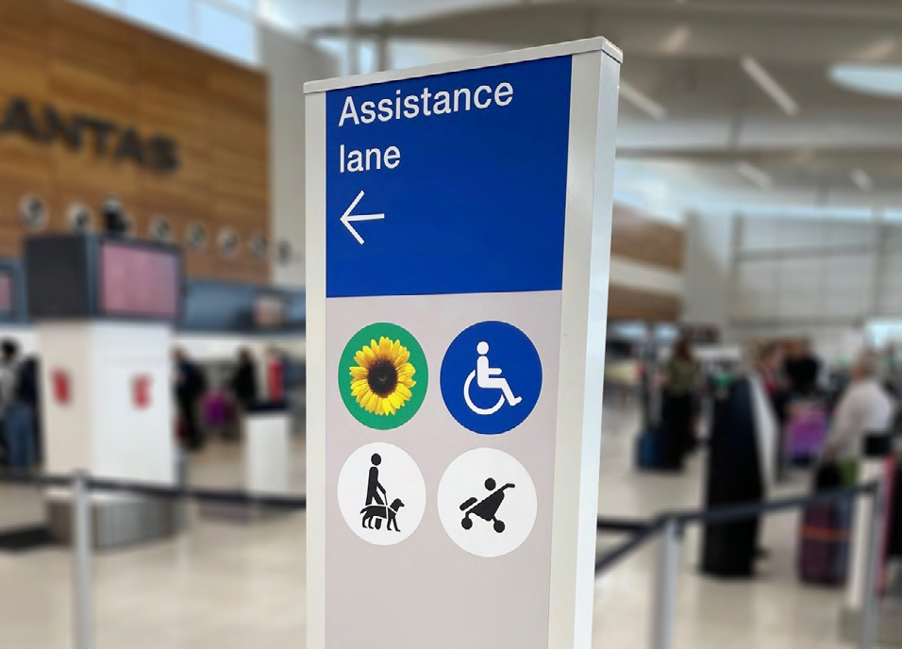

What to do With Your Bags and Items
When you reach the trays, place your bags and loose items into trays for X-ray screening. Use a separate tray for each bag and place the trays onto the conveyor belt.

Comfort Items and Disability Supports
If you use disability-related comfort or communication items to manage screening, let staff know. This might include noise-cancelling headphones, ear defenders, a fidget, sunglasses, or a communication device. You can usually keep these with you, but staff may ask to check them.

Mobility Aids and Medical Devices
If you use a mobility aid, have metal implants, or use medical devices (for example a pacemaker, insulin pump, or glucose monitor), tell staff before you join the queue. If you have a doctor’s letter or manufacturer guidance for your device, have it ready to show staff.

Screening Methods and What to Expect
You cannot choose your screening method, but staff will take your needs into consideration. If you can use the body scanner, follow staff instructions. If the scanner alarms, try not to panic, it often just means something needs to be double-checked. If you cannot be screened using the body scanner, staff will use alternative screening methods. You can ask to be screened by an officer of the gender you feel most comfortable with, and you can choose whether screening happens in the public area or in a private room. Alternative screening may include a pat-down, a hand-held metal detector wand, and/or Explosive Trace Detection (ETD), which is a gentle swab test on you or your items. Screening may involve a combination of methods.

Assistance Animals
If you are travelling with an assistance animal, you can choose to have your dog remain with you or be screened separately. Staff may also screen your dog’s lead, collar, harness, or jacket.

Security Screening with a Disability
Watch this video for an example of what security screening with a disability can be like.
Link: Click here for the video

After Screening
Once staff confirm screening is complete, collect your items from the end of the conveyor belt. If you need help reaching anything, ask a staff member.

If You Need Help Right Now
Customer Service Officers can assist with wheelchair support, luggage handling, and wayfinding guidance in the terminal.

If You’ve Booked Assistance
Aim to be at your gate at least 45 minutes before boarding. This gives airline staff plenty of time to get you set up, whether that’s helping you board, supporting you with mobility aids, or simply making sure you’re ready when your flight is called. Adelaide Airport also recommends arriving at the gate early so staff can coordinate your boarding.

Getting to Your Gate and Boarding

Finding your Gate
Once you’ve cleared security, you’ll see overhead signs with gate numbers and arrows straight ahead. You’ll also see flight information screens around the terminal. These screens show flight numbers, boarding times, and gates.
Gate numbers can change, so it’s worth checking the screens again every so often, especially if you’ve been sitting for a while. The walk from the end of the security screening area to the furthest gate (Gate 50) is about 350 metres. If that distance might be difficult for you, it’s best to organise help early.

Arrange Mobility Help to Your Gate
At Adelaide Airport, gate-to-gate mobility support is usually arranged through your airline (or their ground handling team), not booked directly through the airport.
The practical move is to request mobility assistance from your airline in advance, or confirm it at check-in. Airlines commonly provide support from check-in to the departure gate when requested.
If you didn’t arrange it ahead of time, go to your airline staff at check-in or the gate and ask what options are available for your flight.

At Your Gate

Seats
All gates have comfortable seats with USB and USB-C charging ports. Priority seating for people with disabilities is available at the front of gates. Look for the disability symbols on the seats.
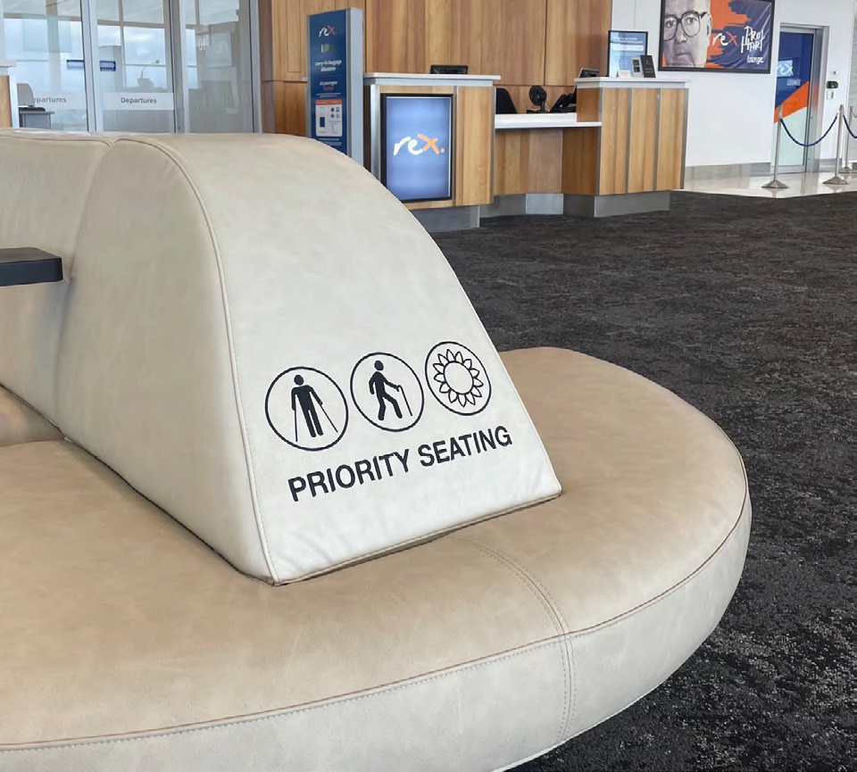

Priority Boarding
If you have a mobility aid or assistance dog, most airlines will automatically board you first to give you time to get on the plane comfortably and privately. If you do not have these but would prefer to board first or last, for example, to help you manage anxiety, just ask the staff at the gate.
Scripts to ask for priority boarding
“Hi, could I please pre-board today?”
“Hi, I have an access need. Could I board early so I have a bit more time?”
“Hi, could I please do priority boarding? I’d like a quieter, less rushed boarding process.”
To ask to board last (boarding after most people)
“Hi, could I please board last today?”
“Hi, I have an access need and I do better boarding after the queue has cleared. Is boarding last possible?”
“Hi, could you let me know when the last call is so I can board after most passengers?”
If staff ask why (optional)
“It helps me manage anxiety and sensory overload.”
“It helps me board safely and calmly.”
You don’t need to share a diagnosis. It’s enough to explain what you need, like extra time, less crowding, or clear instructions.

Arrivals Process
Follow the Signs
After you get off the plane, follow the Arrivals and Baggage signs. If you are meeting someone, keep an eye out for signs to the exit and public meeting areas.
If You Have Assistance Booked
If you have airline assistance booked, stay near the aircraft door or the waiting area and let staff take the lead. Assistance can include support getting off the plane, moving through the terminal, and help with mobility aids. If you are unsure what is happening, ask a staff member:
“Hi, I have assistance booked. Can you tell me what happens next?”
Mobility Aids and Equipment
Your airline will tell you where your wheelchair or mobility aid will be returned. This might be at the aircraft door or at baggage reclaim. If you need your chair immediately on arrival, ask staff as soon as you land so they can organise it early.

Baggage Reclaim
If you have checked bags, go to the baggage carousel for your flight. Check the screens for your flight number to confirm which carousel to use. If you need help lifting bags or reaching items, ask a staff member or a Customer Service Officer. Look for floor decals at baggage carousels that provide space for passengers with a disability.
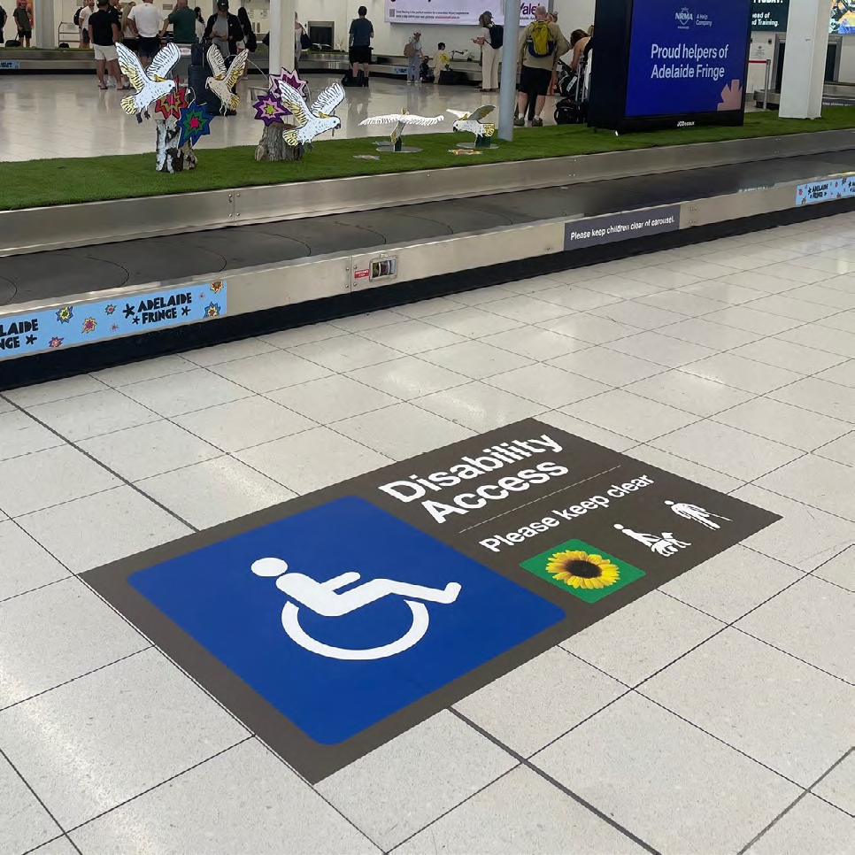

Meeting Points
If you have checked bags, go to the baggage carousel for your flight. Check the screens for your flight number to confirm which carousel to use. If you need help lifting bags or reaching items, ask a staff member or a Customer Service Officer.

Getting out of the Airport
The same transport options apply when you arrive and when you depart. See the earlier section Getting to and from Adelaide Airport for full details.

Pick-Up & Drop-Off
If someone is collecting you, they can use the general pick-up area or the Access Zone near Atura Hotel if that is easier for you. Remind drivers there are time limits and they may need to do a lap and come back if you are delayed.

Taxi & Accessible Taxi
Taxis are available at the taxi rank outside the terminal. If you need a wheelchair-accessible taxi, it is usually best to pre-book. If you have trouble finding the rank, ask staff to point you in the right direction.

Public Transport (Bus)
Adelaide Metro buses connect the airport to the city and suburbs. If you are tired or travelling with luggage, allow extra time and plan for the short walk between the stop and the terminal.

Rideshare
Rideshare pick-up is in the designated pick-up area. Accessible rideshare options can be limited, so a pre-booked accessible taxi may be more reliable.

Thank You for using this Access Guide!
We hope it helps you feel informed and supported when travelling through Adelaide Airport. If you have feedback or suggestions, we would love to hear from you. Your feedback helps us keep improving
access and inclusion for everyone.
Email: accessandinclusion@aal.com.au
Phone: 08 8154 9587
Text: 0485 990 823

